Worksheet 3.2

Student Name: Sahil Kaundal UID: 21BCS8197

Branch: CSE (Lateral Entry) Section/Group:20BCS-807_B Semester: 4th Date of Performance: 02/05/2022

Subject Name: SE Lab Subject Code: 20CSP-255

Q1.

1. Aim/Overview of the practical:

Design a structure chart for a student registration process who is taking admission in a college/university.

1. Task to be done/ Objective:



Design a structure chart for a student registration process who is taking admission in a college/university.

Structure chart is a chart derived from DFD. It breaks down the entire system into lowest functional modules, describes functions and sub-functions of each module of the system to a greater detail than DFD.

Structure chart represents hierarchical structure of modules. At each layer a specific task is performed.

1. Requirement Analysis:

Software Requirement:

* Smart Draw
* Google Chrome
* Excel

Hardware Requirement:

* Computer
* Windows 10
* Power Supply

Structure Charts:

Structure Chart represent hierarchical structure of modules. It breaks down the entire system into lowest functional modules, describe functions and sub-functions of each module of a system to a greater detail. Structure Chart partitions the system into black boxes (functionality of the system is known to the users but inner details are unknown). Inputs are given to the black boxes and appropriate outputs are generated.

Modules at top level called modules at low level. Components are read from top to bottom and left to right. When a module calls another, it views the called module as black box, passing required parameters and receiving results.

Symbols used in construction of structured chart

1.  Module

It represents the process or task of the system. It is of three types.

2· Control Module

A control module branches to more than one sub module.

3· Sub Module

Sub Module is a module which is the part (Child) of another module.

4· Library Module

Library Modules are reusable and invoke able from any module.

Structure chart for a student registration process who is taking admission in a college/university.

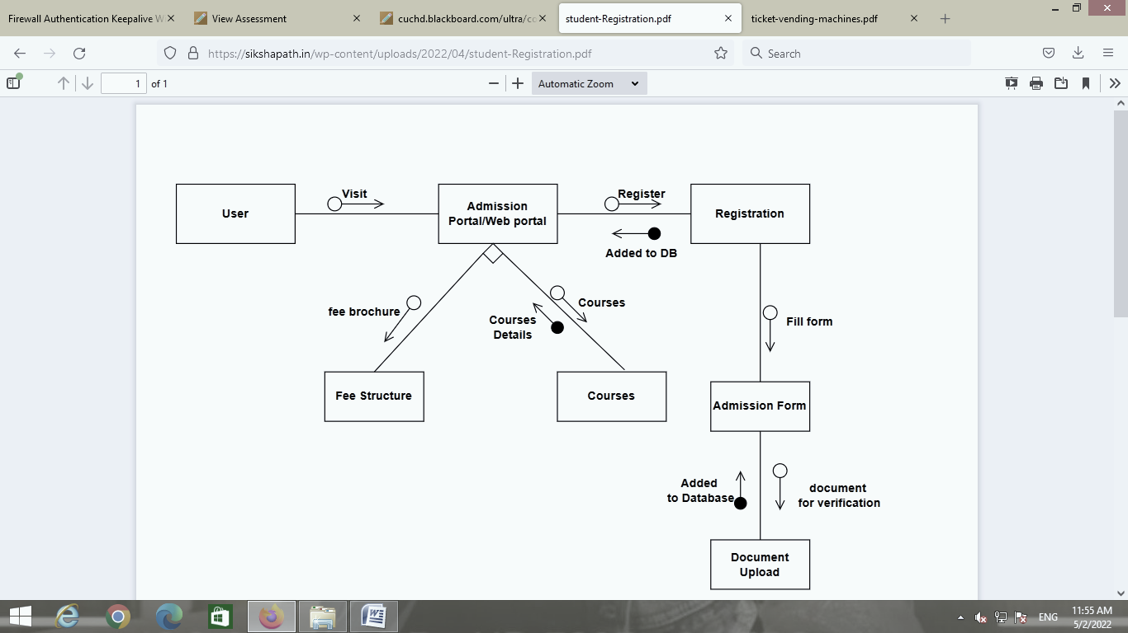

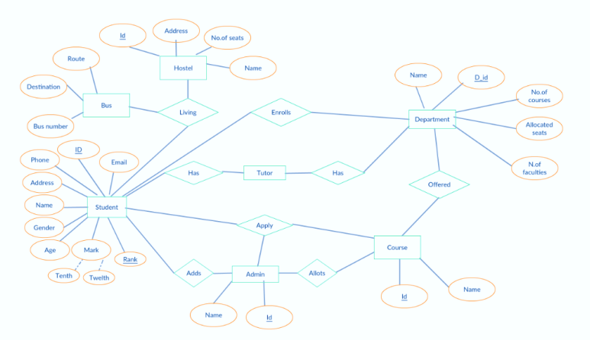

Q2.

1. Aim/Overview of the practical:

Design a structure chart for a ticket vending machine at a metro station.

1. Task to be done/ Objective:



Design a structure chart for a ticket vending machine at a metro station.

Structure chart is a chart derived from DFD. It breaks down the entire system into lowest functional modules, describes functions and sub-functions of each module of the system to a greater detail than DFD.

Structure chart represents hierarchical structure of modules. At each layer a specific task is performed.

1. Requirement Analysis:

Software Requirement:

* Smart Draw
* Google Chrome
* Excel

Hardware Requirement:

* Computer
* Windows 10
* Power Supply

Structure Charts:

Structure Chart represent hierarchical structure of modules. It breaks down the entire system into lowest functional modules, describe functions and sub-functions of each module of a system to a greater detail. Structure Chart partitions the system into black boxes (functionality of the system is known to the users but inner details are unknown). Inputs are given to the black boxes and appropriate outputs are generated.

Modules at top level called modules at low level. Components are read from top to bottom and left to right. When a module calls another, it views the called module as black box, passing required parameters and receiving results.

Symbols used in construction of structured chart

1.  Module

It represents the process or task of the system. It is of three types.

2· Control Module

A control module branches to more than one sub module.

3· Sub Module

Sub Module is a module which is the part (Child) of another module.

4· Library Module

Library Modules are reusable and invoke able from any module.

Design a structure chart for a ticket vending machine at a metro station.

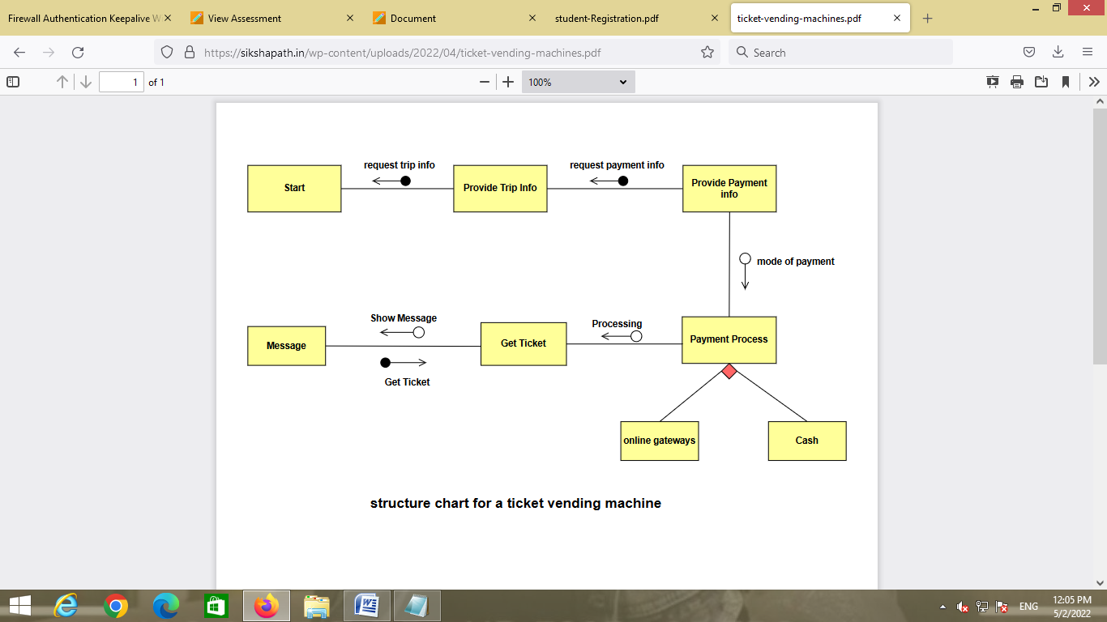

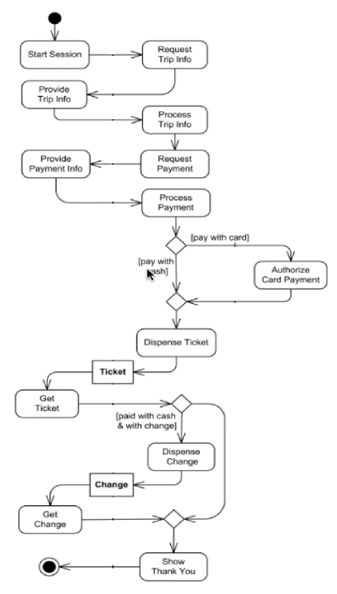

1. Result/Output/Writing Summary:

I have successfully done this practical.

Learning outcomes (What I have learnt):

1. Learned about Structure Chart.
2. Learned about structure chart for a student registration process who is taking admission in a college/university.
3. Learned about a structure chart for a ticket vending machine at a metro station.

Evaluation Grid (To be created as per the SOP and Assessment guidelines by the faculty):



|  |  |  |  |
| --- | --- | --- | --- |
| Sr. No. | Parameters | Marks Obtained | Maximum Marks |
| 1. |  |  |  |
| 2. |  |  |  |
| 3. |  |  |  |
|  |  |  |  |